Tips for Recording

- Prepare your surroundings. Choose a quiet and aesthetically pleasing environment. Some background elements typically look better on-air than a blank wall (bookcases, shelves, art, etc.).
  - Check for any background elements that are directly behind your head and may be distracting.
  - Be sure to remove any unprofessional or personal items you don’t want shared.
  - Avoid interruptions. If you are presenting from home with multiple people or pets, be sure to let everyone know ahead of time that you will be doing a presentation and secure your presentation space.

- Close other programs on your computer and silence devices. Make sure all other windows on your computer are closed (especially if they make noise). Silence your cell phone and landline if nearby. If your mouse is not silent when advancing slides, use arrow keys on the keyboard instead.

- Test the technology. Do a “dry run” to make sure your technology is working. Make sure you have command of any keystrokes you may need to adjust volume or video.

- Look at the camera, not the screen. It is very tempting to watch yourself or your slides during a virtual presentation, but looking directly at the video camera is the only way to maintain direct eye contact with your audience.

- Dress the part. Treat your virtual events as you would an in-person event.

- Watch your body language. Not all physical cues translate from in-person events to virtual events, which make the ones that do even more important. Be sure to have good posture and relax your shoulders to avoid stiffness. Sit on the edge of your chair to demonstrate engagement.

- Remember - the rules of engagement do not change. Treat virtual presentations the same as any other event. Act as though you are live. Everything is on the record - be prepared to deliver your message!

- Re-watch your presentation. Check the audio, visual, and that you have kept to time

Zoom Recording Instructions

- Navigate to https://zoom.us/ and log in or create an account.

- In the upper right-hand corner, click “Host a Meeting” and select “With Video On.”

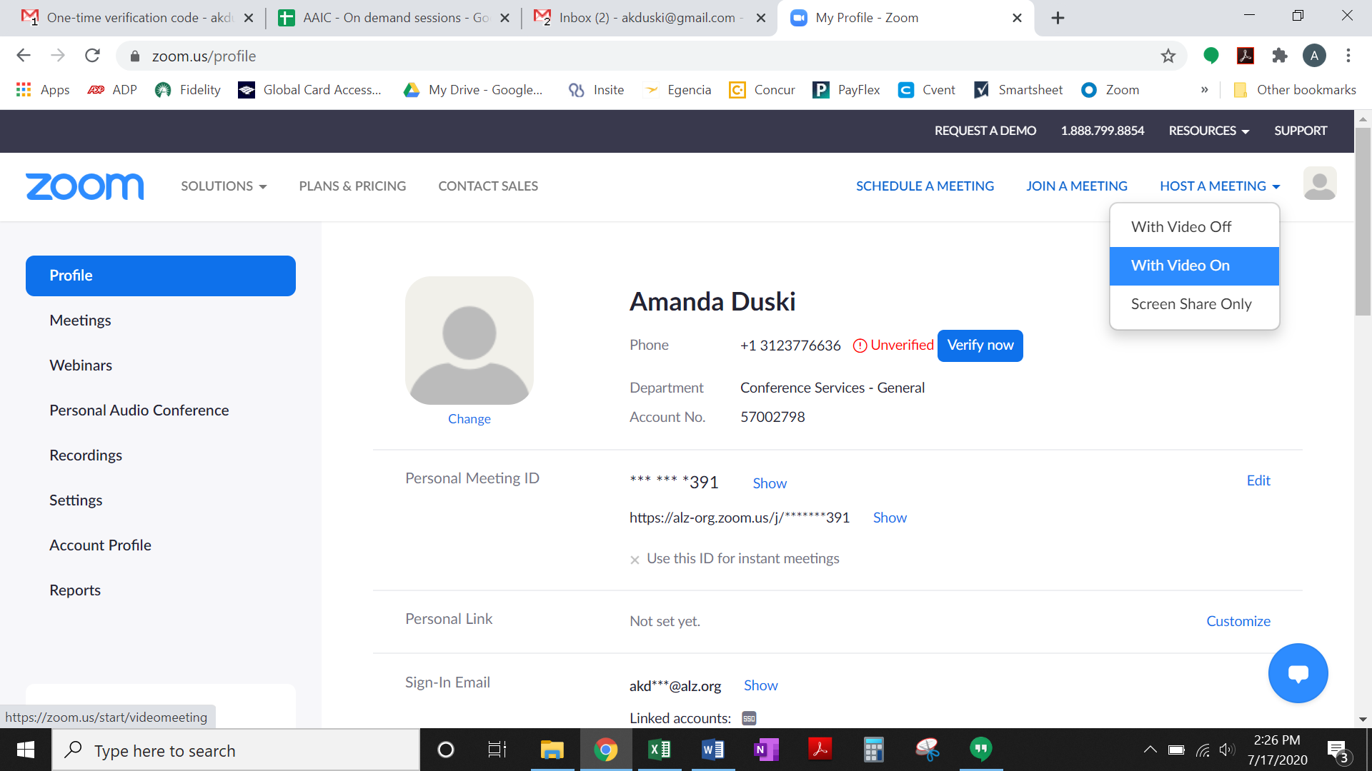

- Click “Open Zoom Meetings” or “Open Zoom Launcher” (depending on where the application opens on your computer). You may need to download the Zoom application if it isn’t already installed on your computer.

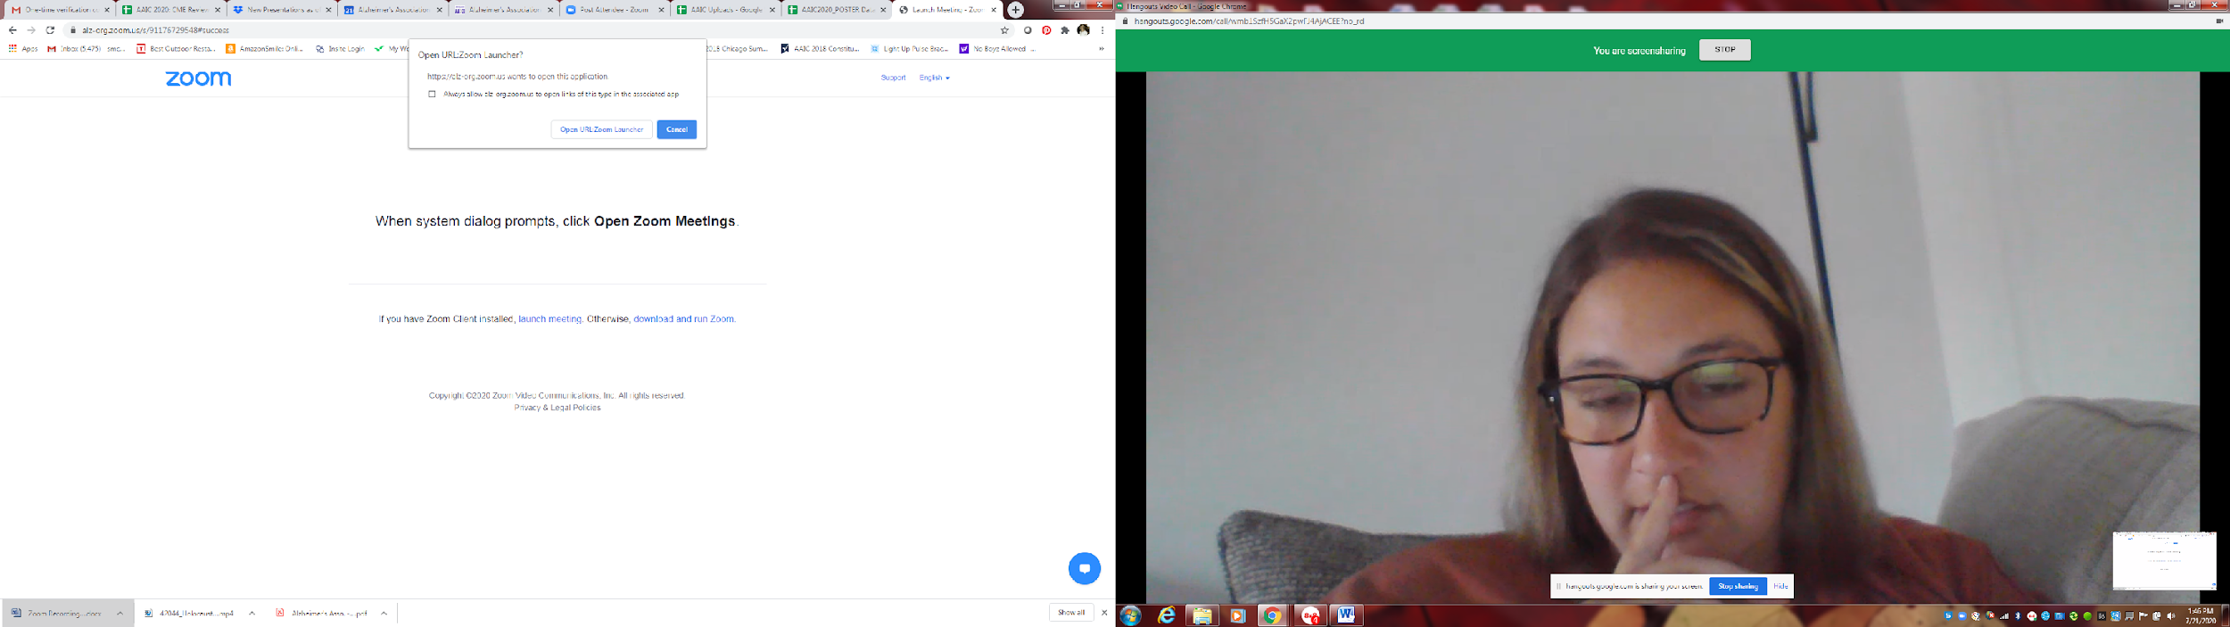
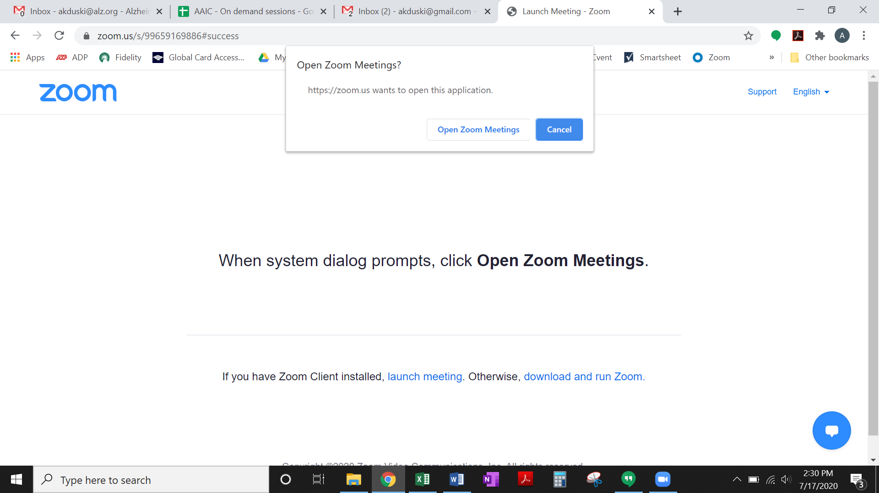

- Click “Test Speaker and Microphone.”

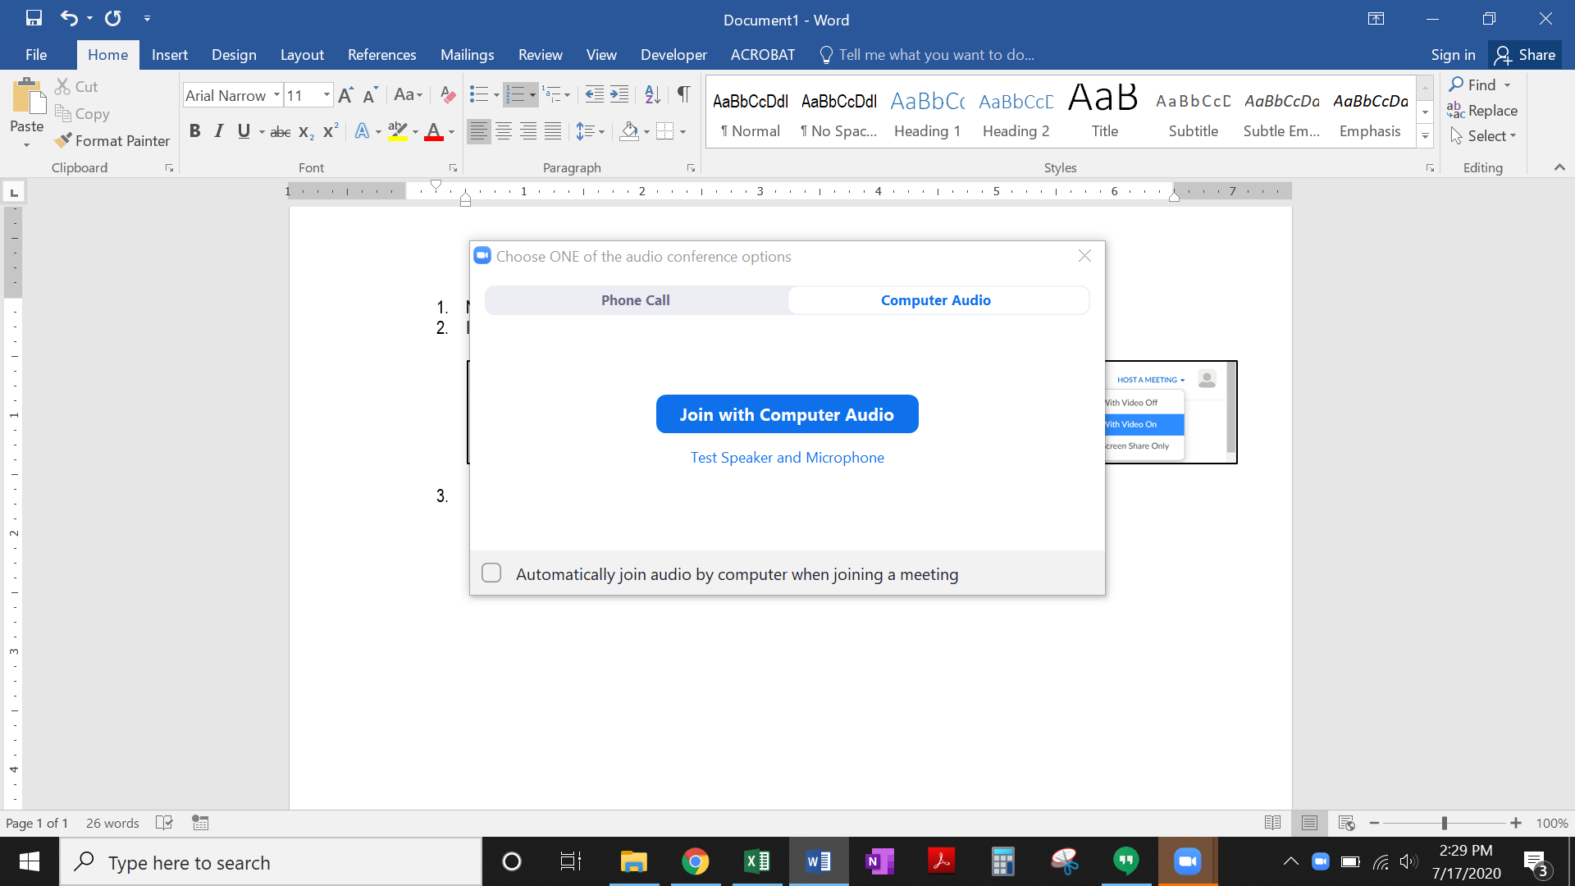

- After confirming your speaker and microphone are working properly, click “Join with Computer Audio.”
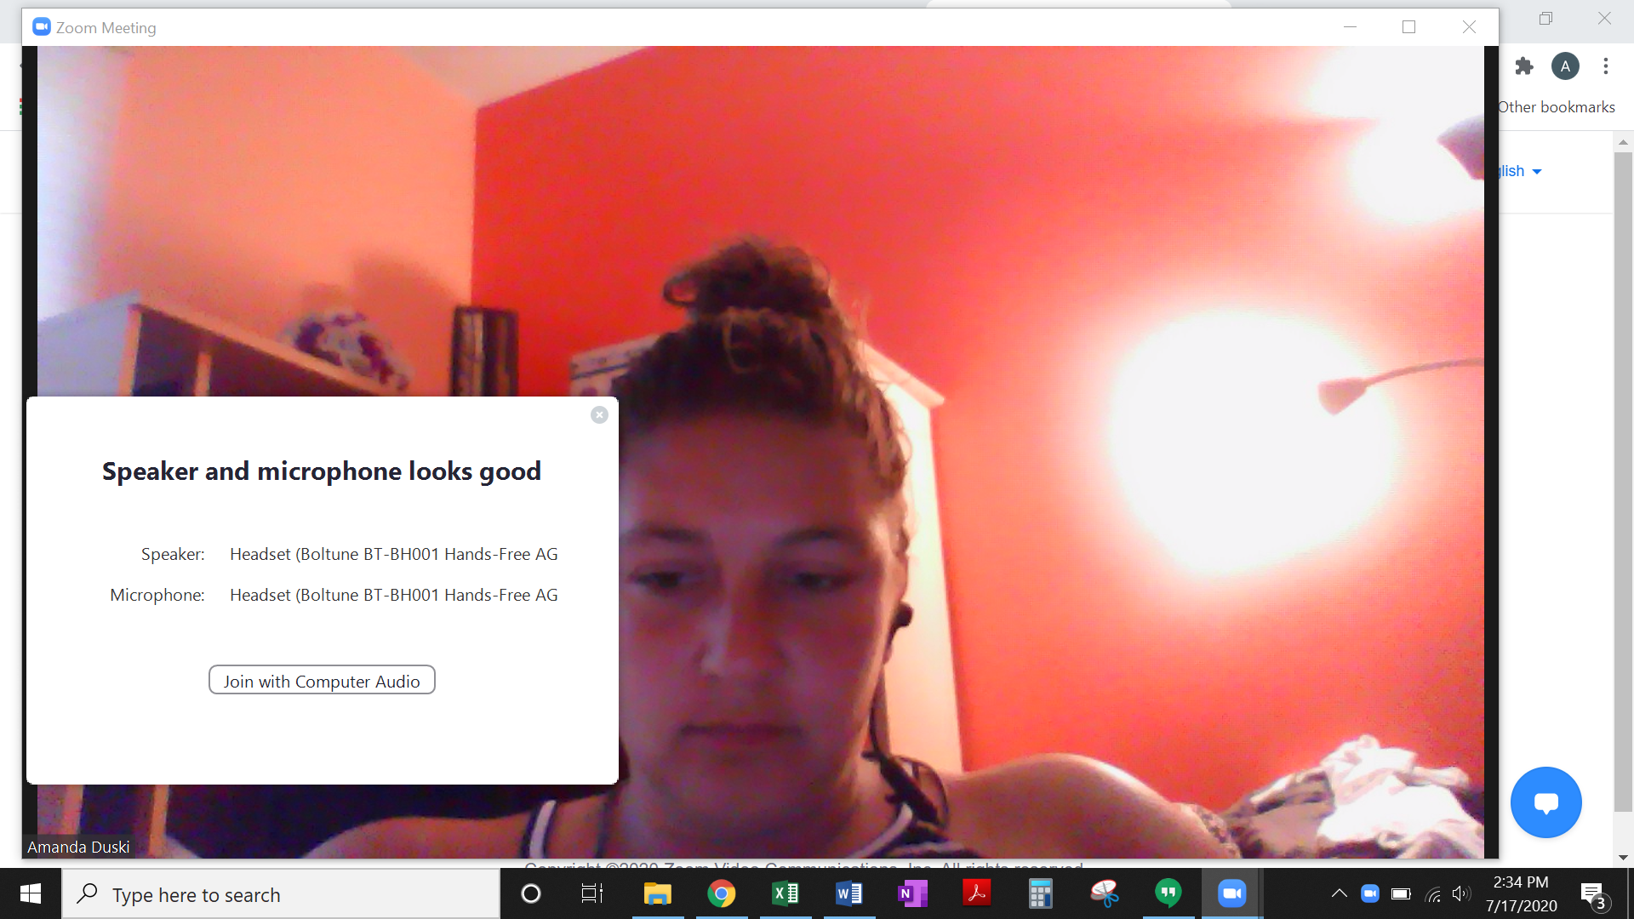

- Make sure your PowerPoint presentation is open. Then, click “Share Screen” on the task bar.

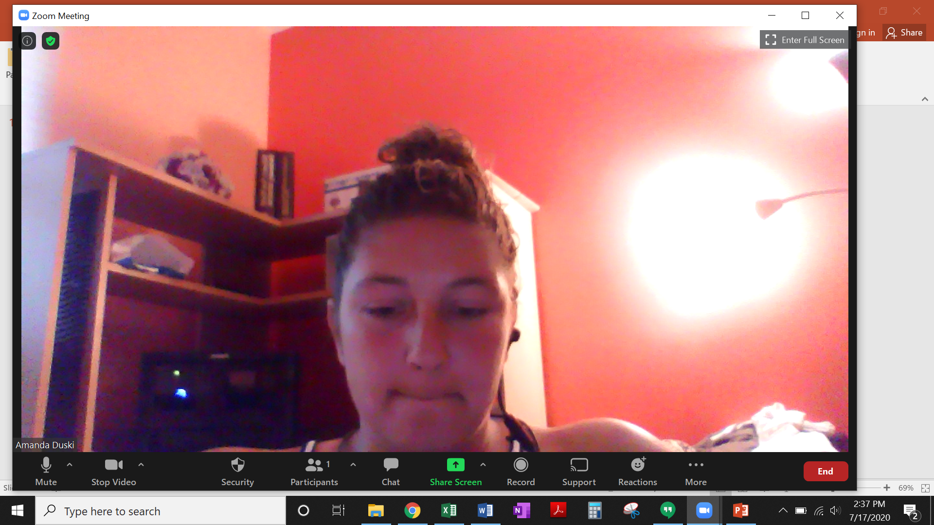

- Select your PowerPoint presentation and click “Share.”

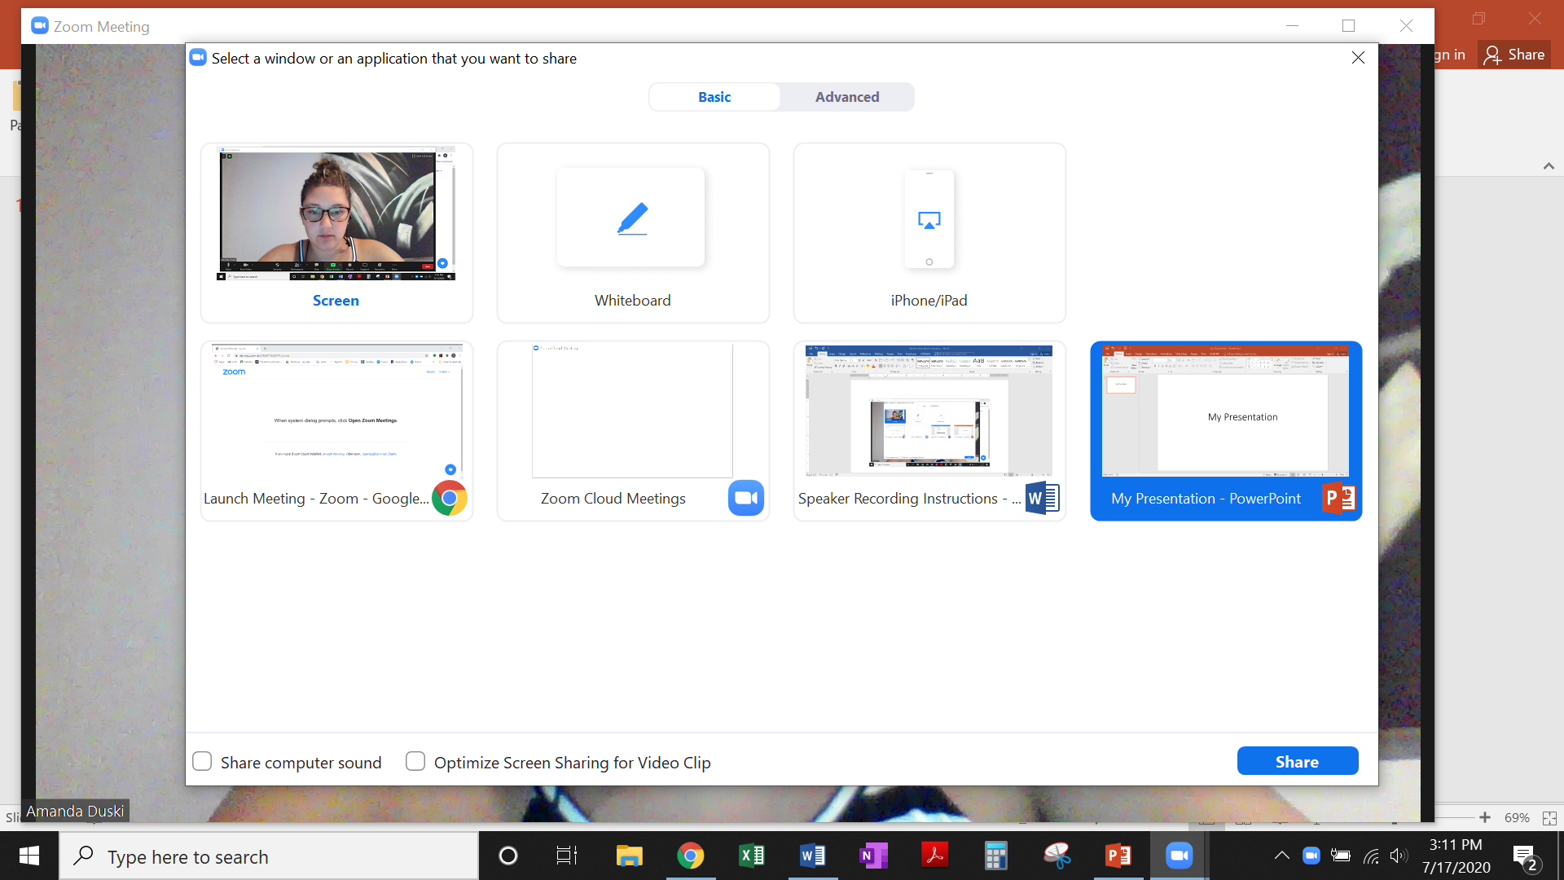

- Enter slideshow mode by clicking on the icon in the bottom right-hand corner, or by clicking the “Slide Show” tab and then “From Beginning.”


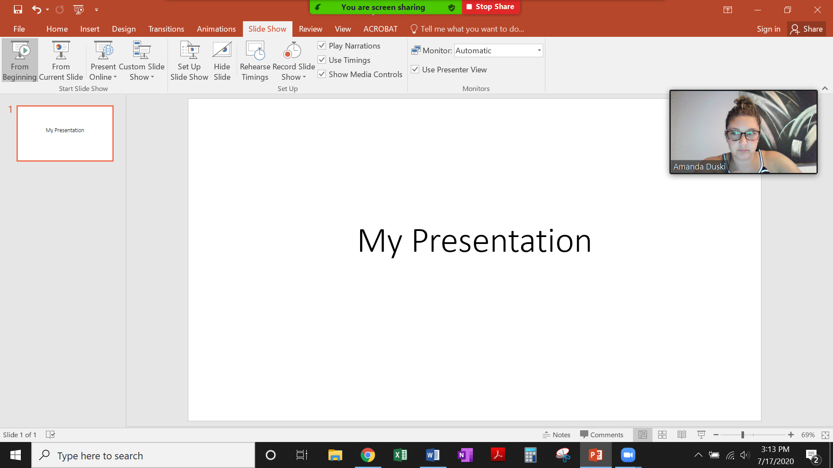

- Ensure that the video of yourself in the top right corner does not obstruct any information on your slides.

- Hover over the “You are screen sharing” green bar to view the task bar. Click “More” and then “Record on this Computer.”

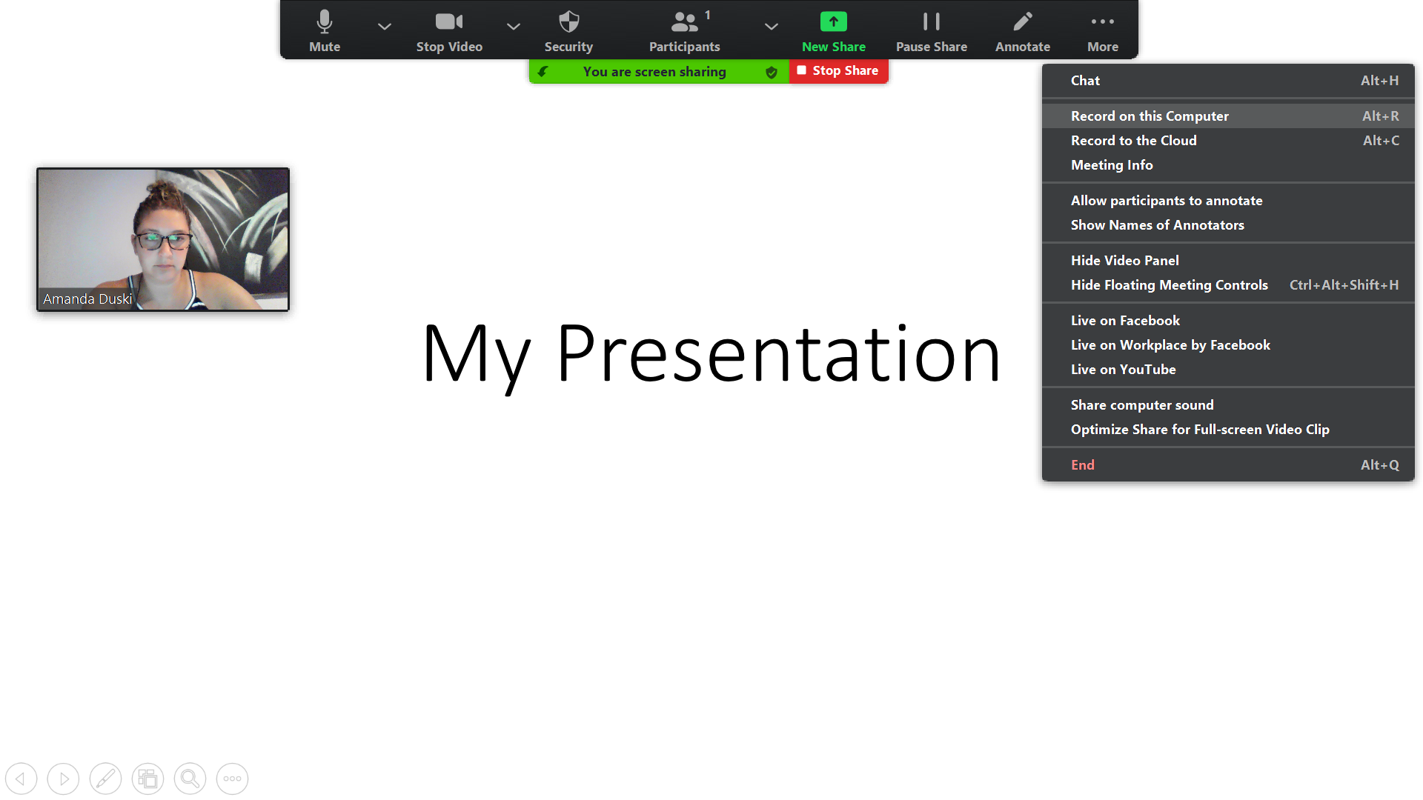

- When you are finished with your presentation, hover over the “You are screen sharing” green bar to view the task bar. Click “More” and then “Stop Recording.”

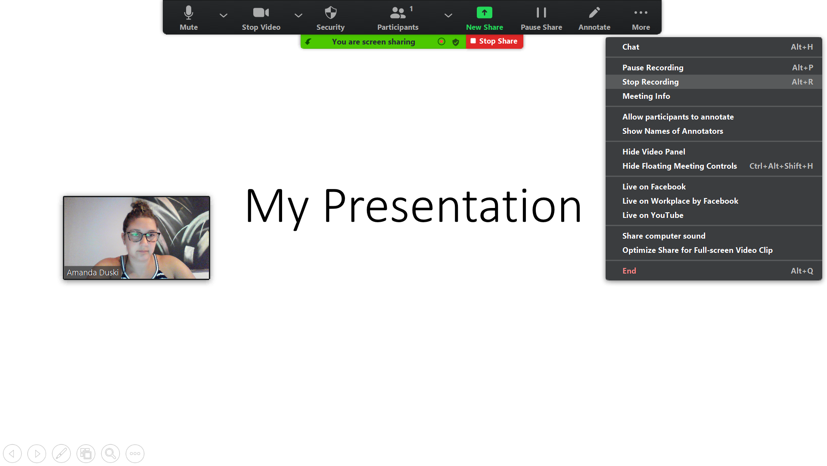

- Click “Stop Share.”

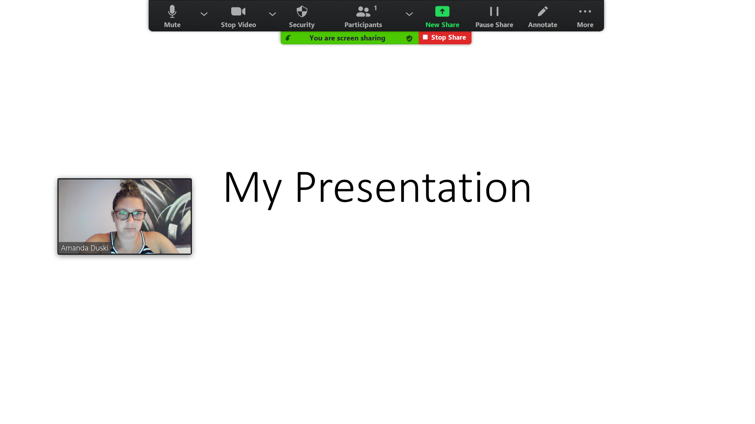

- Click “End” and then “End Meeting for All.”

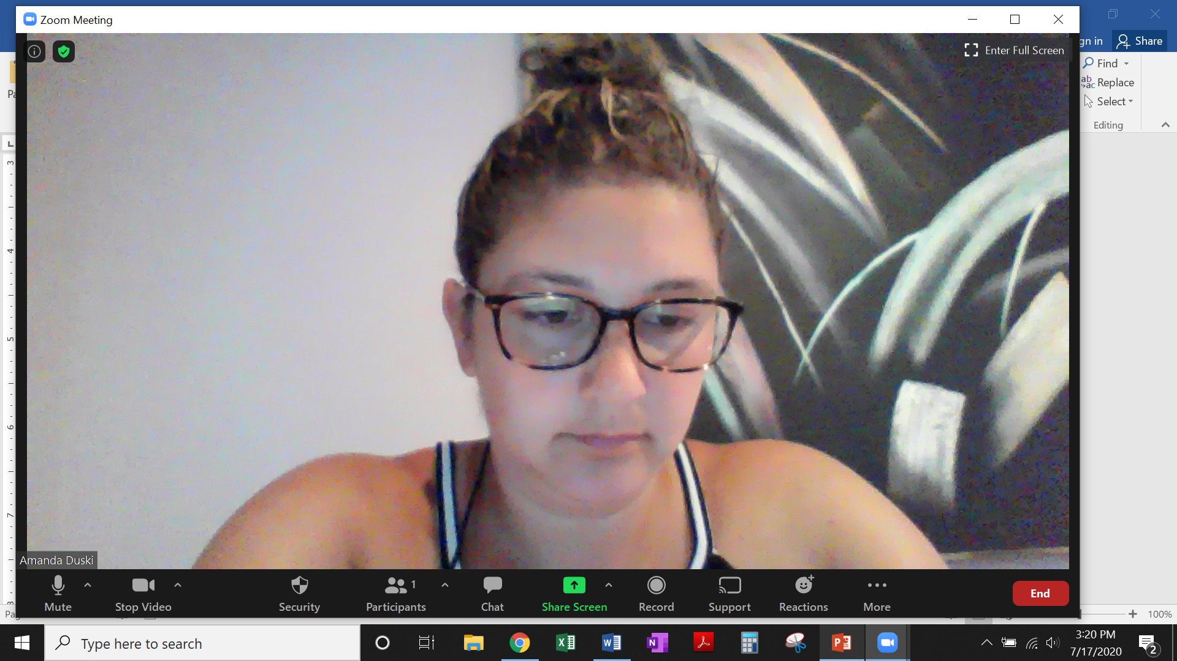

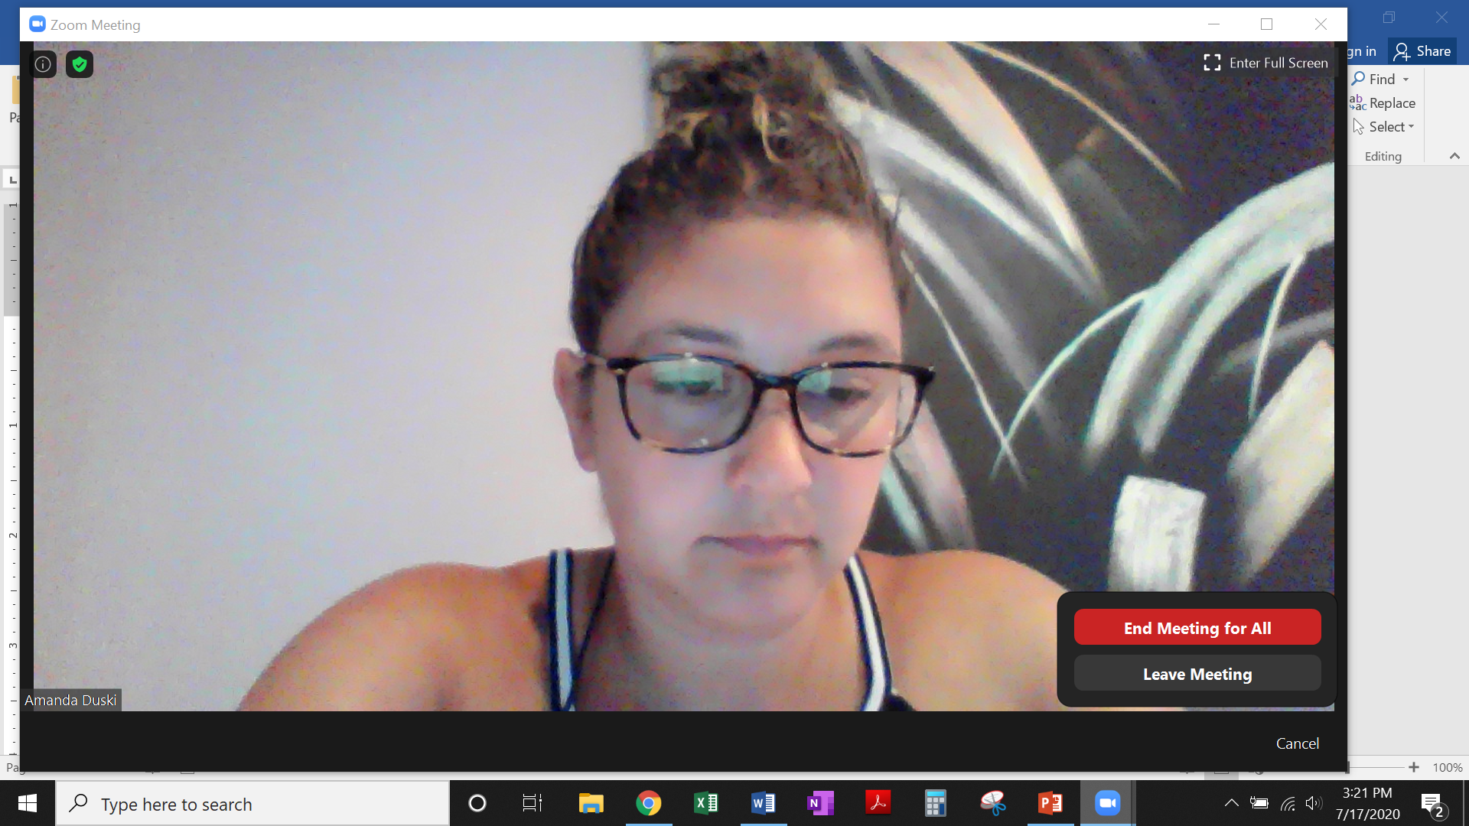

- Zoom will automatically start converting your recording to an mp4 file once the meeting has ended.

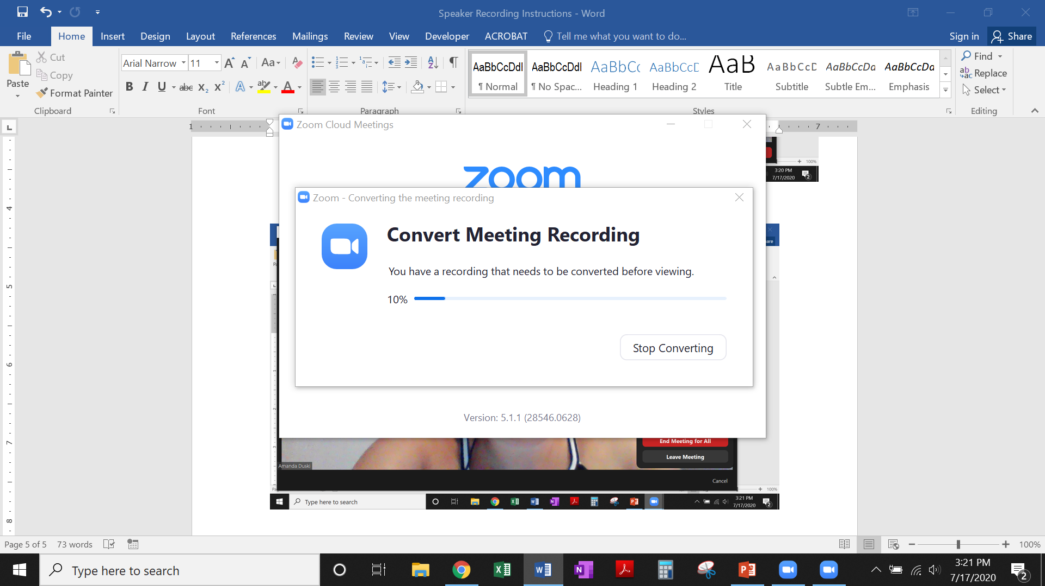

- Select a folder to save your file.

